LOW-LEVEL DESIGN DOCUMENT

**HEALTH INSURANCE DATA ANALYSIS AND REPORTING USING POWER BI**

**Created Date: 23/03/2023.**

TABLE OF CONTENTS

CONTENT

1. Loading csv file into SQL Server Database
2. Created dimension tables using fact table.
3. SQL Database Connection to Power BI Desktop
4. Importing data from SQL Server Database to Power BI Desktop
5. Imported Data into Power BI Desktop
6. Create a relationship between dimension tables and fact tables in model view.
7. Creating reports based on the requirement.

1.Loading csv file into SQL Server Database

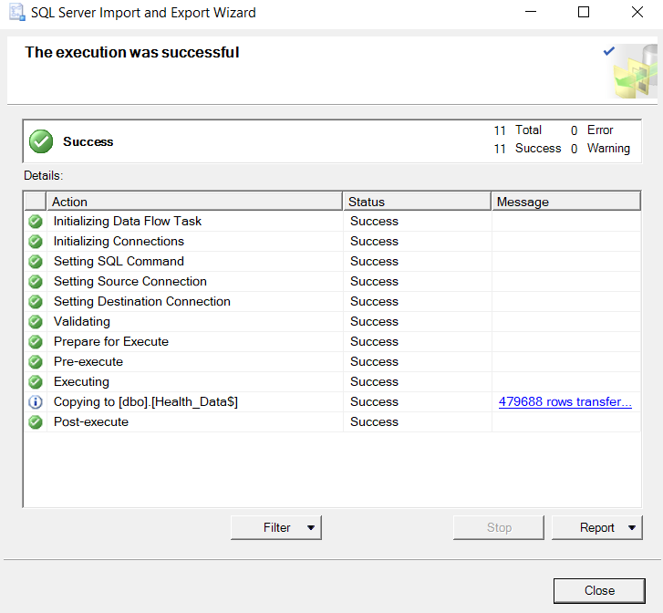

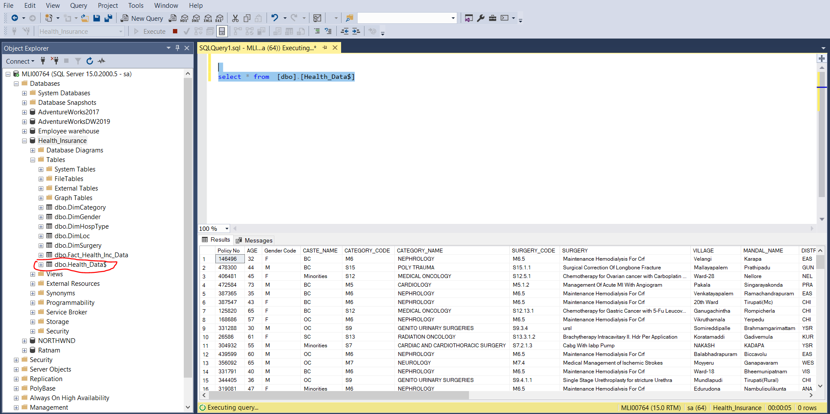

2. Created dimension tables using fact table

3. SQL Database Connection to Power BI Desktop

4. Importing data from  SQL Server Database to Power BI Desktop

5.Dimesion tables & Fact tables In power BI desktop

6. Create a relationship between dimension tables and fact tables in model view

6. Creating reports based on the requirement

Use cases:

Health Insurance is looking to integrate raw data in to MSSQL Server Database to generate data driven reports .

* Analyzing Hospital level wise Total policy Information
* Identifying different Surgeries and amount spent on surgeries.
* Gender wise analysis in health insurance policies
* Location wise and category wise policy and amount information

Hospital wise total policy report

Surgery wise report:

Gender wise report:

Location wise report:

Category wise report:

